MTG Card API – Step-by-Step Project Documentation
1. Project Goal
Build a beginner-friendly API that:
- Integrates with an external API (Scryfall)
- Uses JSON data
- Exposes custom endpoints
- Calculates estimated pull odds
- Simulates a Randomized Magic The Gathering booster pack opening from card set.
This demonstrates:
- API integration
- JSON parsing
- Query parameters
- Randomization
- Backend API development

2. Environment Setup
Step 2.1 – Create project directory
mkdir mtg_api_project
cd mtg_api_project
Step 2.2 – Create virtual environment
python3 -m venv venv
Step 2.3 – Activate virtual environment
source venv/bin/activate
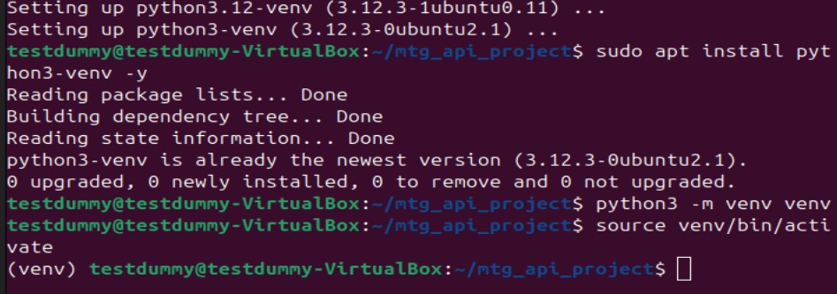
Step 2.4 – Install dependencies
pip install fastapi uvicorn requests
- FastAPI → web API framework
- Uvicorn → runs the server
- Requests → makes HTTP calls to Scryfall
Afterwards, prove dependencies are installed:
pip show fastapi uvicorn requests

You should see info for all three packages.
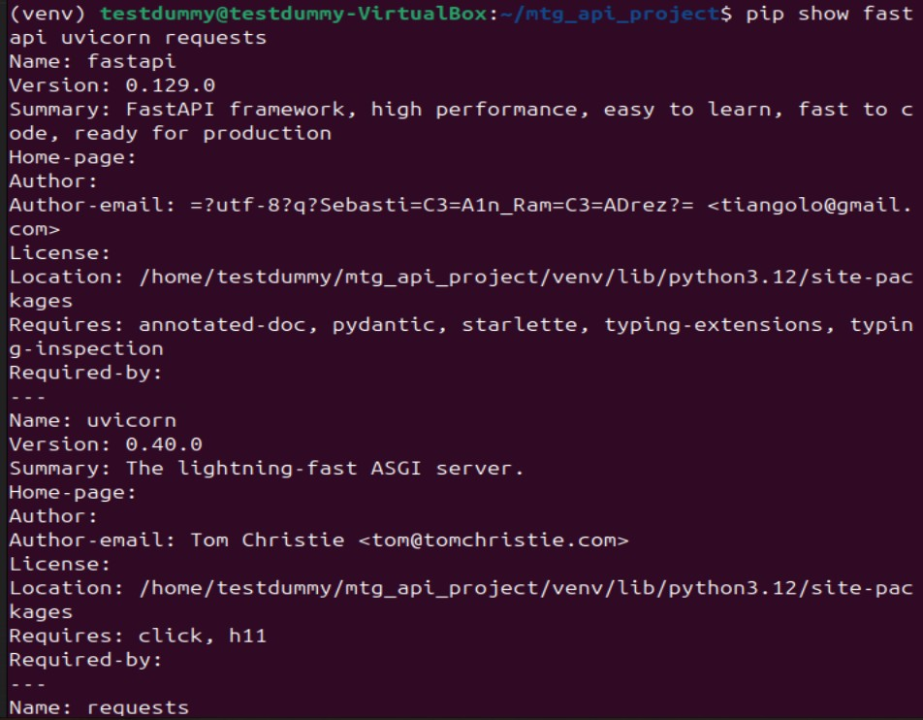

3. Create the API file
Create the main API file:
nano main.py

4. Build the /card endpoint (API Integration)
Purpose:
Fetch a card from Scryfall and return structured JSON with pull odds.

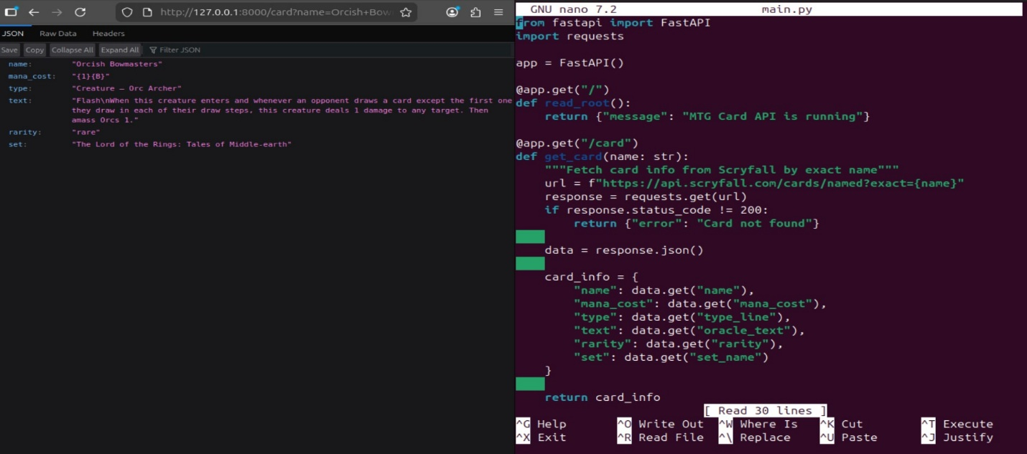

Run this command:
uvicorn main:app --reload
Explanation:
- uvicorn → starts the server
- main:app → main.py file and the app object inside it
- --reload → automatically reloads if we change the code

Terminal will show something like:
INFO: Uvicorn running on http://127.0.0.1:8000 (Press CTRL+C to quit)
Open your VM browser and go to that url.

5. Add Pull Odds Mapping
Create a dictionary to map rarity to estimated odds:
Type:
nano main.py

odds_mapping = {
"common": "10 per booster (~66%)",
"uncommon": "3 per booster (~20%)",
"rare": "1 per booster (~12.5%)",
"mythic": "1 per 8 boosters (~1.5%)"
}
This shows:
- Data processing
- Business logic
- Probability mapping
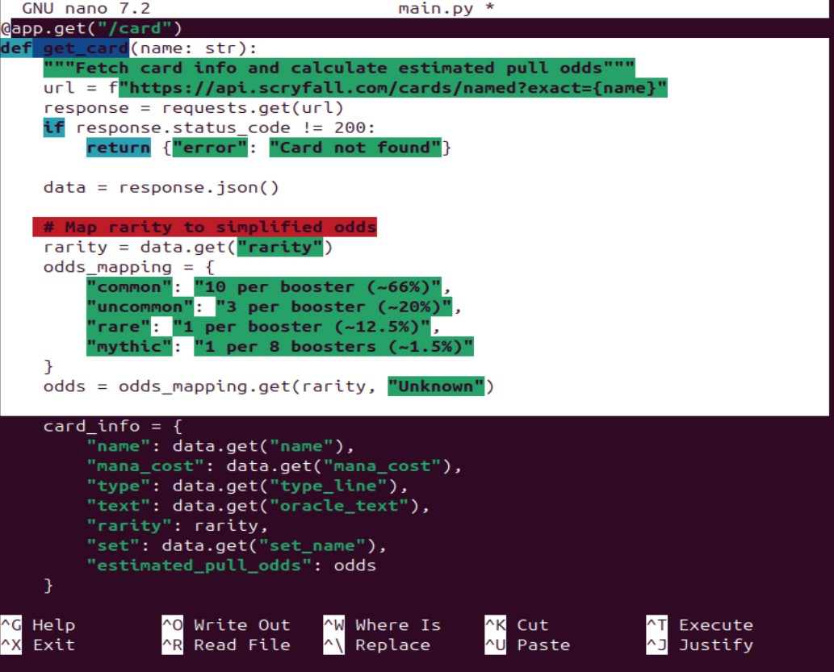
Added the estimated pull odds for card per booster pack:
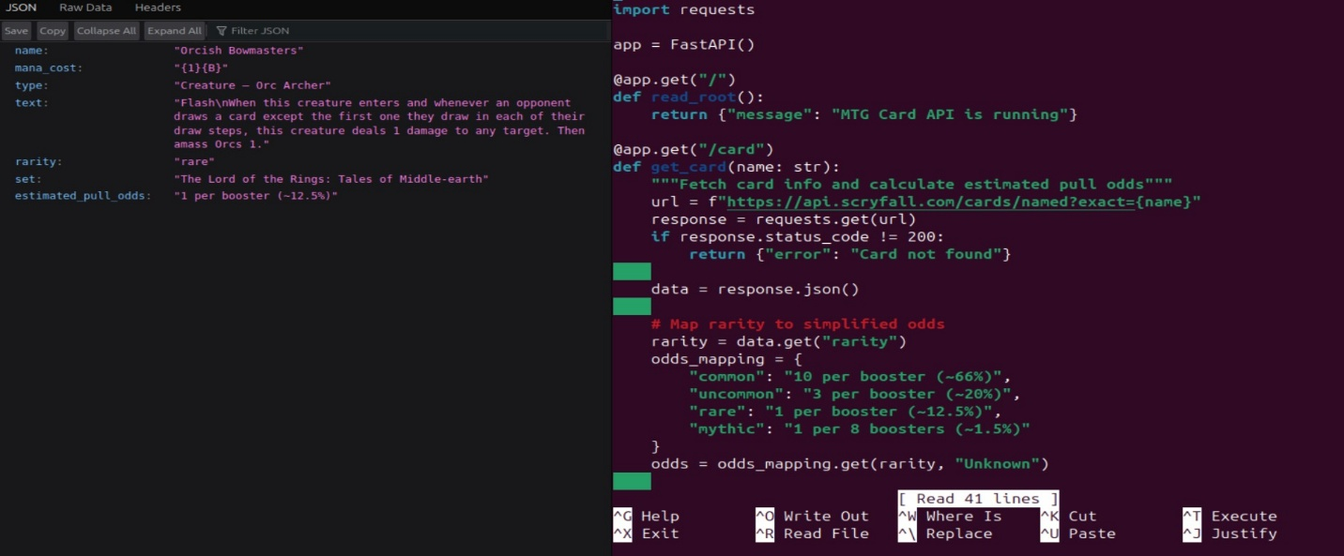

6. received error code: 422 Unprocessable Entity Error (Important Learning Moment)
Problem:
FastAPI returned:
422 Unprocessable Entity
Cause:
Query parameters were not explicitly defined.
Solution:
Used FastAPI Query(...):
def get_card(name: str = Query(...)):
and
def get_booster(set_code: str = Query(...)):
This taught:
- How FastAPI handles query parameters
- How to debug API errors
- How to document mistakes and solutions

7. Build the /booster endpoint (Booster Simulator)
Purpose:
Simulate opening a booster pack from a set.

5. Add Pull Odds Mapping
Create a dictionary to map rarity to estimated odds:
Type:
nano main.py

User request:
/booster?set_code=jou
What happens:
- API fetches all cards in a set from Scryfall
- Separates them by rarity:
  - commons
  - uncommons
  - rares
  - mythics
- Randomly selects:
  - 10 commons
  - 3 uncommons
  - 1 rare or mythic
- Returns a JSON booster pack
This demonstrates:
- Randomization
- Lists and filtering
- External data processing
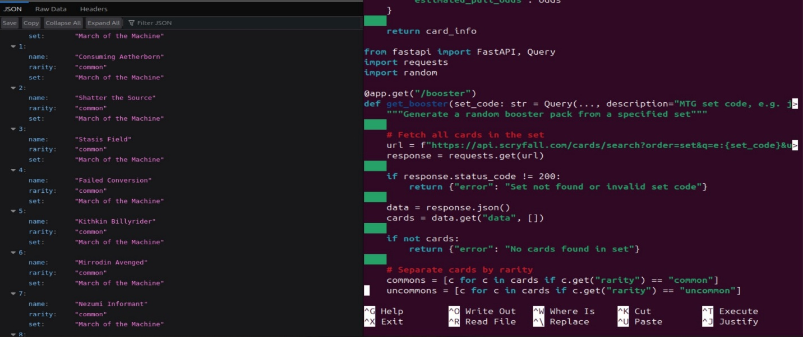

8. Add Odds to Each Booster Card in the randomizer
Enhanced the booster output:
"estimated_pull_odds": odds_mapping.get(c.get("rarity"))
Now each card in the booster includes:
- name
- rarity
- set
- estimated pull odds
This shows:
- Combining two features (booster + odds)
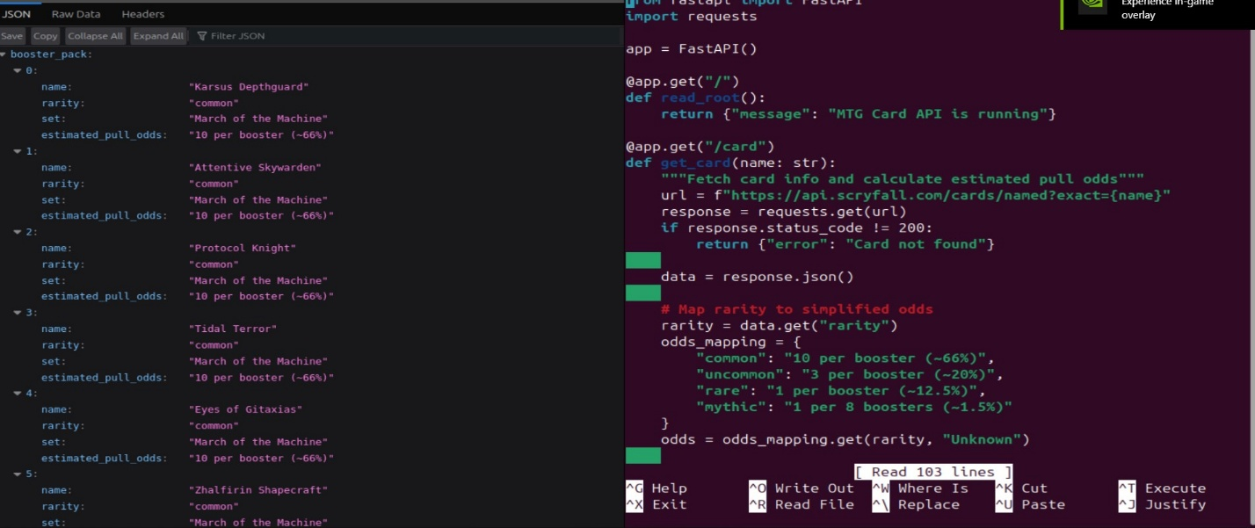

9. Testing the API
Used browser to test endpoints:
http://127.0.0.1:8000/card?name=Lightning+Bolt
http://127.0.0.1:8000/card?name=orcish+bowmasters
Booster pack set randomizer:
http://127.0.0.1:8000/booster?set_code=mom
http://127.0.0.1:8000/booster?set_code=jou

Confirmed:
- JSON returned correctly
- Random booster changes each refresh
- Odds included
- No more 422 errors

Source:
https://scryfall.com/docs/api

